Lab Exercise 10: Arm CMSIS and Software Drivers

# Overview

In previous labs, we used C language to program the system. However, C often takes time to access each peripheral register in the low-level. In this lab, we will program the processor using functions from libraries.

In this lab, the work includes:

* Software programming:
* Configure the Cortex-M0 processor using Arm CMSIS (Cortex Microcontroller Software Interface Standard).
* Write software drivers for the hardware peripherals.
* Demonstrate the SoC:
* Use the timer interrupt to increment a counter in every second and display the counter on the 7-segment display (using driver functions).
* Use the UART interrupt to send characters to a PC or laptop (using driver functions).
* Input from an 8-bit switch and output to LEDs (using driver functions).

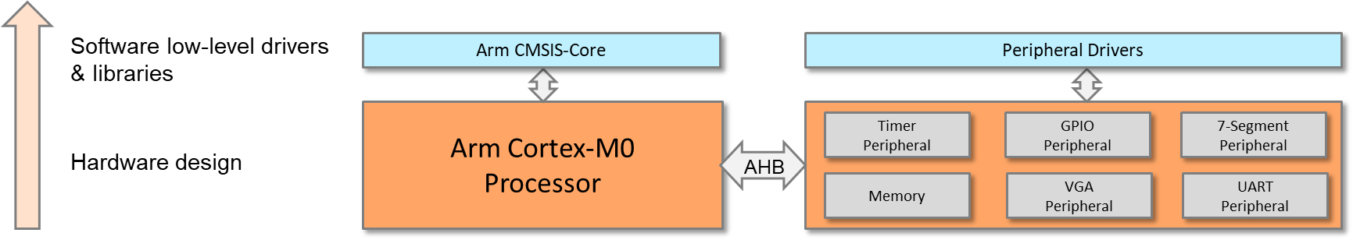

**Program SoC using CMSIS and Peripheral Drivers**

# Details

## software

### RESTRUCTURE YOUR FILES

To use CMSIS, the files need to be included in your project.

Before adding CMSIS, it would be better to restructure our project repositories. Suggestions are as follows:

1. Under your μvision project directory, create a new folder called “Application” and move the main program file “main.c” into this folder. This folder should contain files used for application programming.
2. Under the project directory, create a new folder called “Device” and move the assembly file “cm0dsasm.s” into this folder. This folder should contain files that are specific to the device, e.g., software drivers for peripherals.
3. Reopen the project and remove all groups and files.
4. Create two new groups and name them “Application” and “Device”.
5. Move “main.c” and “cm0dsasm.s” to “Application” and “Device,” respectively.

### Add CMSIS files to your project:

1. Under the project directory, create a new folder called “Core” that will contain processor-related files.
2. Copy the CMSIS files into the folder; the files include:

|  |  |
| --- | --- |
| **File name** | **Description** |
| core_cm0.h | CMSIS Cortex-M0 core peripheral access layer header file |
| core_cmFunc.h | CMSIS Cortex-M core function access header file |
| core_cmInstr.h | CMSIS Cortex-M core instruction access header file |

1. Under the “Device” folder, create a new header file called “EDK_CM0.h” (educational development kit); this will be used to define our SoC and its peripherals.
2. In “EDK_CM0.h,” define the interrupt number, processor core, system memory, and peripheral memory map.
3. Include the path of all header files to your project (Project Configuration 🡪 C/C++ 🡪 Include Paths).

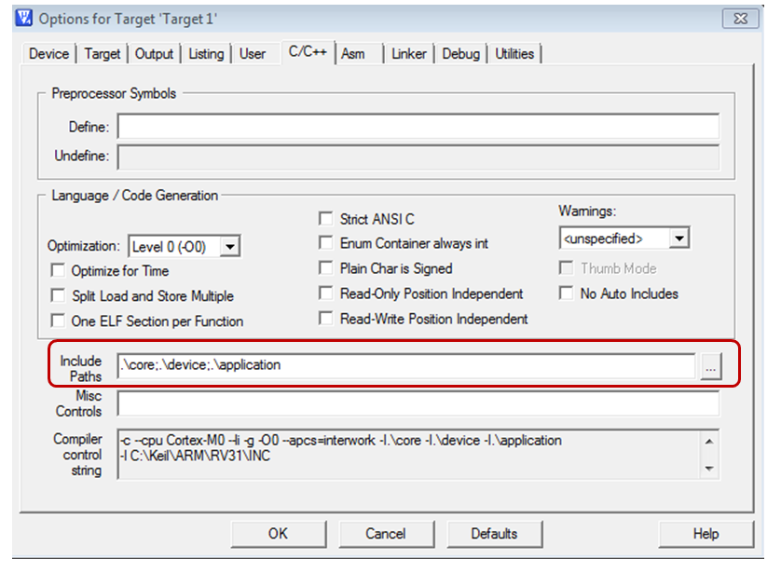

1. Rewrite your program using CMSIS functions.

### CREATE AND USE YOUR OWN SOFTWARE DRIVERS

1. Under the “Device” folder, create a new file named “edk_driver.c”; this will contain the driver functions for all peripherals.
2. Under the “Device” folder, create another file called “edk_driver.h”; this will include the names of functions in “edk_driver.c”.
3. Add the files to your project.
4. Include “edk_driver.h” in your main program.
5. Write software functions for your peripherals. Suggested functions are as follows:

|  |  |
| --- | --- |
| **File name** | **Description** |
| cm0dsasm.s | Includes interrupt vectors and other setup assembly code |
| main.c | Includes the main program and interrupt service routines |
| EDK_CM0 | Defines the interrupt numbers and memory map etc. |

### file structure

Core folder

Device folder

Application folder

core_cm0.h

cm0dsasm.s

main.c

core_cmFunc.h

core_cmInstr.h

EDK_CM0.h

edk_driver.c

edk_driver.h

EXAMPLE FUNCTIONS

|  |  |  |
| --- | --- | --- |
| **Peripheral** | **Function** | **Description** |
| VGA | void VGA_plot_pixel (int x, int y, int col); | Plot a pixel in the image region. |
| 7-segment display | void seven_seg_write(char dig1, char dig2,char dig3,char dig4); | Write four digits on the 7-segment display. |
| Timer | void timer_init (int load_value, int prescale, int mode); | Initialize the timer. |
| void timer_enable(void); | Enable the timer. |
| void timer_irq_clear(void); | Clear interrupt request from the timer. |
| GPIO | int GPIO_read(void) | Return with the value read from the input port. |
| void GPIO_write(int data) | Write a value to the GPIO output. |

### program procedure

At this stage, the processor and the peripherals should be accessed through functions, rather than through writing/reading registers.

The assembly code in cm0dsasm.s will perform the following:

* Initialize the interrupt vector.
* Define heap and stack.
* Reset handler.
  + Branch to the main code in main.c.
* Timer handler
  + Push registers (e.g., R1 – R4) to the stack.
  + Branch to the timer interrupt service routine in main.c.
  + Pop registers from the stack.
* UART handler
  + Push registers (e.g., R1 – R4) to the stack.
  + Branch to the UART interrupt service routine in main.c.
  + Pop registers from the stack.

The C code in main.c should perform the following:

* Main program
  + Initialize the processor and the nested vectored interrupt controller (NVIC) using CMSIS functions.
  + Enable the interrupts using CMSIS functions.
  + Initialize and start the timer using timer driver functions.
  + Then repeat the following:
    - Read the value from the switches using GPIO functions.
    - Write the value to the LEDs using GPIO functions.
* Timer interrupt handler
  + Clear the timer interrupt request using the timer driver function.
  + Increment the counter.
  + Display the counter to the 7-segment in decimals using driver functions.
* UART interrupt handler
  + Read from the UART (from the keyboard) using UART driver functions.
  + Write to the UART (to the terminal window) using UART driver functions.

# extension work

Here are some extra things that you can do:

* Explore the other functions provided by CMSIS, e.g., special instructions and control pending status of interrupts.
* Develop more driver functions for your peripherals.